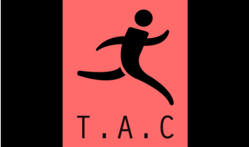

Tavistock Athletic Club Safeguarding Policy & Procedures

As a responsible Athletics Club we will:
- Adopt national welfare policies and procedures, adhere to the codes of conduct and respond to any suspected breaches in accordance with the Welfare Procedures
- Appoint a welfare officer, preferably two, one male and one female, and ensure that they are provided with appropriate training to act as a first point of contact for concerns about welfare issues
- Ensure that all staff and volunteers operating within the club environment hold the appropriate qualifications and have undertaken the appropriate checks e.g. DBS, licences, qualifications such as massage, sports nutrition etc
- Ensure that coaches, technical officials and club officers attend recommended training in welfare and safeguarding and protecting children as appropriate.
- Liaise appropriately with parents/persons with parental responsibility, officials, coaches, sports scientists, national governing bodies and other relevant people/organisations to ensure that good practice is maintained
- Ensure that information is available at the club and to all club officers, team managers, coaches and officials regarding contact details for local social services, the police and the NSPCC
- Ensure that club officers and volunteers always act responsibly and set an example to others including younger members
- Respect the rights, dignity and worth of every club member and others involved in athletics and treat everyone equally.
- Consistently promote positive aspects of the sport such as fair play and never condone rule violations or the use of prohibited or age-inappropriate substances
- Challenge inappropriate behaviour and language by others
- Place the welfare and safety of the athlete above other considerations including the development of performance
- Report any suspected misconduct by club officials, coaches, technical officials or other people involved in athletics to the Club, Regional, National or UKA welfare officer as soon as possible

