TAVISTOCK A.C.
JUNIOR WELCOME PACK
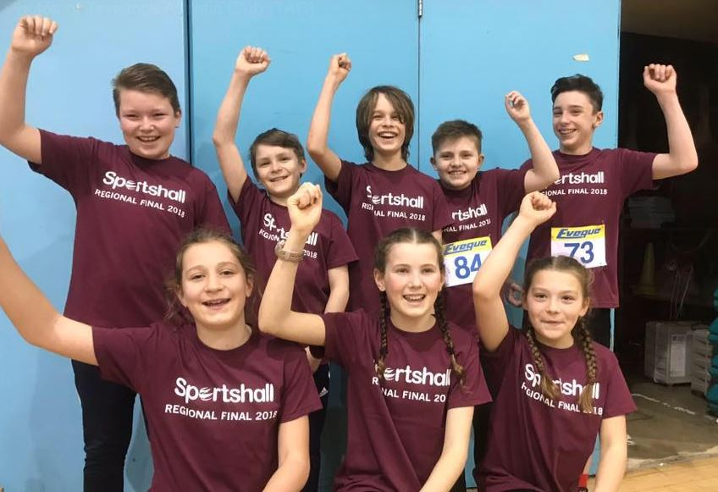

Contents:

In this pack you will find the following information:

- Welcome Letter

- Junior Training Information

- Coaching Structure

- Competitions

- Club Kit

- Club rules

- Code of Conduct for Junior Athletes

- Code of Conduct for Parents / Carers

- Club Welfare Officer

- Contacts

Tavistock Athletic Club Welcome!

Dear Parent/Carer/Junior

On behalf of Tavistock Athletic Club I would like to welcome you to the club and provide you with some information about us.

The club provides opportunities for athletes from the age of 8 and year 4 in school upwards to receive coaching and compete in a wide range of athletic disciplines, such as Track & Field, Cross Country, Sports hall and Road Running. We have a team of experienced and qualified coaches who have been screened for their suitability for working with young people, who will help you with all aspects of your athletic development.

This welcome pack will provide you with more information about the club such as training times, competition opportunities, club kit, club rules, responsibilities and codes of conduct.

You should already have completed a junior club membership form and paid your annual subscription, if not please do so as soon as possible. This is needed in order to comply with the club’s insurance. Please keep the club informed of any changes to your medical or contact information to ensure your safety at all times. Subscriptions are due annually by the end of February. You will be notified by email of the amount due, after the club AGM.

We welcome parents to all training sessions and competitions and value your support in all aspects of the club. We are keen to try and involve parents in the club and would like to invite you to attend our training sessions to find out more about the opportunities available to you within the club. We are always looking for volunteers to help with a wide range of activities such as coaching, officiating, registration and providing transport to events.

The club does not just cater for junior athletes. We have a large senior section that competes in athletic competitions and road running events. So if parents are also interested in athletics then they are more than welcome to attend the senior training sessions. They take place on Tuesdays & Thursdays at 6:30pm.

If you would like to talk to someone about your involvement with the club then please contact the club’s Chairman, welfare officer, or one of the coaches.

Alistair Kinsey
Chairman, Tavistock AC.

Tavistock Athletic Club JUNIOR TRAINING INFORMATION

The club has a range of facilities and equipment used within training. The facility and equipment will be chosen based on the competition season and the required session. Facilities used for training include the sports hall, gymnasium, grass fields and the athletics Track. Endurance runs around the town are also part of an athlete’s training.

The juniors can take part in a range of competitions including open meetings and League competitions that take place on the Track, Indoor Sports hall and cross country locations. The clubs 3 main League competitions for the juniors are; The Devon Open Series, The Devon Indoor Sports hall Competition and the Westward League (cross country). We do expect our athletes to compete for the club in some of the competitions mentioned above.

Within athletics, there is something out there for everyone, whether it involves sprinting, Jumping, Throwing, or Endurance and the training on offer gives athletes the opportunity to try them all in a fun and safe environment.

The junior section has a great team of volunteer coaches who spend a lot of time and effort into helping the juniors develop and without them there would not be a junior section. All sessions will be led by a qualified UKA coach who will have undertaken a DBS Check. We are always looking for more coaches or helpers and if you are interested please speak to one of the coaches, who will provide you with more information.
Tavistock Athletic Club Junior Coaching Structure

Tavistock Athletic Club Competitions
As well as weekly training sessions the club offers a wide range of opportunities for you to take part in competitions.

We will provide detailed information about each event in the weeks leading up to it, and we also provide subsidised transport to some events.

As a member of the club you are expected to compete in the events listed previously, for most the competitions you do not have to be selected to compete, you can just turn up when you are available. Do not worry if you have not competed before, the club coaches and other athletes will be happy to help you out, and remember, everyone has to start somewhere.

Whilst we do give T-shirts to junior members, these are only suitable for U10 and U11 Athletes when competing. For U13 and older Athletes you will need to wear a club vest for competitions.
These are available for you to buy as well as other club clothing stock at reasonable prices. See next below for details...

Tavistock Athletic Club Club Kit
If you compete for the club then you will need a club vest or T-Shirt.

The following kit is available:

Club Vest & Crop Tops
Sizes: XS, S, M, L, XL, XXL
See club website

Hoodies
See club website

Club T-shirts
Free on joining club after first membership payment.
Please contact Membership sectary

Tavistock Athletic Club Rules
Tavistock Athletic Club is fully committed to safeguarding and promoting the wellbeing of all its members. The club believes that it is important that members, coaches, officials , volunteers and parents associated with the club should, at all times, show respect and be encouraged to be open at all times and to share any concerns or complaints that you may have about any aspect of the club with the club committee.

- As a member of Tavistock Athletic Club you are expected to abide by the following club rules:

- All members must compete within the rules and respect coaches, officials, volunteers and their decisions

- All members must respect fellow members and competitors.

- Members should keep to agreed timings for training and competitions or inform their coaches or team manager if they are going to be late.

- Members must wear suitable clothing for training, and the club kit when competing, as agreed with the coach/team manager.

- Members must sign in at all training sessions and pay their membership fees for training or events promptly.

- No members are allowed to smoke on college premises or whilst representing the club at competitions.

- Members are not allowed to consume alcohol or drugs of any kind on the college premises or whilst representing the club.

Tavistock Athletic Club Code of Conduct for Junior Athletes

- Treat others with the same respect and fairness that you wish to receive

- Uphold the same values off the track/field as you do when engaged in athletics

- Anticipate your own needs, be organised and on time

- Thank those who help you participate in athletics

- Inform your coach of any other coaching you receive

- Show patience with and respect diversity in others

- Act with dignity at all times

- Notify a responsible adult if you have to go somewhere

- Strictly maintain a clear boundary between friendship and intimacy with a coach, official or other person with whom you train

- Do not respond if someone seeks private information, unrelated to athletics e.g. home life

- Never accept a lift in cars or invitations into homes on your own or without the prior knowledge and consent of your parent/carer

- Use safe transport or travel arrangements

- Avoid destructive behaviour and leave athletics venues as you find them

- Never engage in any illegal or irresponsible behaviour

- Challenge anyone whose behaviour falls below the expected standards of ‘Athletics Welfare’

- Speak out immediately if anything makes you concerned or uncomfortable (Telling your Parents / Carers and/or the Club Welfare Officer or Head Coach) or if you suspect a club mate has suffered from misconduct by someone else.

Tavistock Athletic Club Code of Conduct for Parents/Carers

- Encourage your child to learn the rules and compete within them.

- Discourage unfair play and arguing with officials.

- Help your child to recognise good performances and effort, not just results.

- Never force your child to take part in sport.

- Set a good example by recognising fair play and applauding the good performances of all.

- Never punish or belittle a child for losing or making mistakes.

- Publicly accept official’s judgements.

- Support your child’s involvement and help them to enjoy their sport.

- Use correct and proper language at all times.

- Do not bring your child along to the club to train if not fit for the session.

- If you do not give permission to use photos of your child and that child represents the club, the onus must be on the individual child and you (the parent/carer) to ensure that they do not pose for group “team/group” photos at any event.

Tavistock Athletic Club Welfare Officer

The Welfare Officer will:

- Deal with confidential matters that may arise related to athletes and have an understanding and an appropriate way to such matters.
- Be responsible for the promotion of codes of conduct to members, parents and young people.
- Receive, record and pass on to the NGB Child Protection officer, any concerns relating to the welfare of young people and vulnerable adults
- Provide advice on the development of activities for young people within the club/organisation.
- Support the registration of all personnel involved in activities for young people with the club/organisation (DBS checks).
- Recognise the difference between poor practice in according to club rules and matters that would be seen as welfare issue.

Tavistock Athletic Club Contacts
Contact can be made via the respective club contact page:

Chair Alistair Kinsey.

Junior Coaching Co-ordinator.

Membership sectary

Club Secretary: Sally Lipscombe

Here are some key websites that you may find useful:

- Tavistock Athletic Club
www.tavistockathletics.co.uk (you can also find our coaches code of conduct, our safeguarding policy & our equity statement here).
- England Athletics
www.englandathletics.org
- British Athletics
http://www.britishathletics.org.uk

- Devon County AA
www.devoncountyaa.co.uk
- Power of 10
www.thepowerof10.info

